CBIR: Content Based Image Retrieval

By
Rami Al-Tayeche (237262)
&
Ahmed Khalil (296918)

Supervisor: Professor Aysegul Cuhadar

A report submitted in partial fulfillment of the requirements
of 94.498 Engineering Project

Department of Systems and Computer Engineering
Faculty of Engineering
Carleton University

April 4, 2003

Abstract

The purpose of this report is to describe our research and solution to the problem of designing a Content Based Image Retrieval, CBIR system. It outlines the problem, the proposed solution, the final solution and the accomplishments achieved. Due to the enormous increase in image database sizes, as well as its vast deployment in various applications, the need for CBIR development arose. Firstly, this report outlines a description of the primitive features of an image; texture, colour, and shape. These features are extracted and used as the basis for a similarity check between images. The algorithms used to calculate the similarity between extracted features, are then explained. Our final result was a MatLab built software application, with an image database, that utilized texture and colour features of the images in the database as the basis of comparison and retrieval. The structure of the final software application is illustrated. Furthermore, the results of its performance are illustrated by a detailed example.

Acknowledgements

We would like to thank our supervisor Professor Aysegul Cuhadar for her continuous feedback and support throughout the year that helped us throughout our project. We would also like to thank Professor Richard Dansereau, Assistant Professor at the Department of Systems and Computer Engineering, for his feedback. Furthermore, we acknowledge the support and feedback of our colleagues and friends, Osama Adassi, Nadia Khater, Aziz El-Solh, and Mike Beddaoui.

Table of Contents

1. Introduction to CBIR 1
1.1 Definition 1
1.2 Applications of CBIR 2
1.3 CBIR Systems 2
2. Problem Motivation 3
3. Problem Statement 4
4. Proposed Solution 4
5. Accomplishments 5
6. Overview of Report 5
7. Background 6
7.1 Colour 6
7.1.1 Definition 6
7.1.2 Methods of Representation 7
7.2. Texture 10
7.2.1 Definition 10
7.2.2 Methods of Representation 11
7.2.2.1 Co-occurrence Matrix 12
7.2.2.2 Tamura Texture 14
7.2.2.3 Wavelet Transform 15
7.3 Shape 18
7.3.1 Definition 18
7.3.2 Methods of Representation 19
8. Project Details 20
8.1 Colour 20
8.1.1 Quadratic Distance Metric 20
8.1.2 Histograms 20
8.1.3 Similarity Matrix 21
8.1.4 Results 25
8.2 Texture 29
8.2.1 Pyramid-Structured Wavelet Transform 29
8.2.2 Energy Level 30
8.2.3 Euclidean Distance 31
8.3 GUI 31
8.4 Database 34
8.5 Example 34
8.5.1 Colour Extraction & Matching 35
8.5.2 Texture Extraction & Matching 37
9. Conclusions 38
10. References 40
11. Appendices 43
Appendix - A: Recommended Readings 43
CBIR Systems 43
Haar Wavelet 43
Daubechies Wavelet 43
Appendix - B: MatLab Code 45
aDemo.m 45
decompose.m 54
quadratic.m 54
similarityMatrix.m 55
obtainEnergies.m 56
energyLevel.m 56
euclideanDistance.m 57
displayResults.m 57

List Of Figures

Figure: Sample Image and its Corresponding Histogram… 7
Figure: Image example 13
Figure: Classical Co-occurrence matrix 13
Figure: Haar Wavelet Example… 16
Figure: Daubechies Wavelet Example 17
Figure: Boundary-based & Region-based… [16] 18
Figure: Colour Histograms of two images. 22
Figure: Minkowski Distance Approach… 24
Figure: Quadratic Distance Approach… 24
Figure: Similarity Matrix A, with a diagonal of ones…[3] 25
Figure: Tested Images… 26
Figure: Pyramid-Structured Wavelet Transform. 30
Figure: GUI Design, aDemo.fig… 32
Figure: Menu Editor specification for the menu… 33
Figure: Application window at runtime… 33
Figure: Image Database… 34
Figure: The query image: 371.bmp… 35
Figure: Colour Results for the searching for 371.bmp 36
Figure: Texture Results for the searching for 371.bmp 37

List of Tables

Table: Colour Map for the Previous Image. 8
Table: Colour Maps of two images. 23
Table: Colour Distances for Compressed Images… 26
Table: Colour Distances for Uncompressed Images… 27
Table: Colour distance between query and results… 36
Table: Euclidean distance between query and results… 37

1. Introduction to CBIR
As processors become increasingly powerful, and memories become increasingly cheaper, the deployment of large image databases for a variety of applications have now become realisable. Databases of art works, satellite and medical imagery have been attracting more and more users in various professional fields — for example, geography, medicine, architecture, advertising, design, fashion, and publishing. Effectively and efficiently accessing desired images from large and varied image databases is now a necessity [1].

1.1 Definition
CBIR or Content Based Image Retrieval is the retrieval of images based on visual features such as colour, texture and shape [2]. Reasons for its development are that in many large image databases, traditional methods of image indexing have proven to be insufficient, laborious, and extremely time consuming. These old methods of image indexing, ranging from storing an image in the database and associating it with a keyword or number, to associating it with a categorized description, have become obsolete. This is not CBIR. In CBIR, each image that is stored in the database has its features extracted and compared to the features of the query image. It involves two steps [3]:
- Feature Extraction: The first step in the process is extracting image features to a distinguishable extent.
- Matching: The second step involves matching these features to yield a result that is visually similar.

1.2 Applications of CBIR
Examples of CBIR applications are [4]:
- Crime prevention: Automatic face recognition systems, used by police forces.
- Security Check: Finger print or retina scanning for access privileges.
- Medical Diagnosis: Using CBIR in a medical database of medical images to aid diagnosis by identifying similar past cases.
- Intellectual Property: Trademark image registration, where a new candidate mark is compared with existing marks to ensure no risk of confusing property ownership.

1.3 CBIR Systems
Several CBIR systems currently exist, and are being constantly developed. Examples are [5]:
- QBIC or Query By Image Content was developed by IBM, Almaden Research Centre, to allow users to graphically pose and refine queries based on multiple visual properties such as colour, texture and shape [5]. It supports queries based on input images, user-constructed sketches, and selected colour and texture patterns [2].
- VIR Image Engine by Virage Inc., like QBIC, enables image retrieval based on primitive attributes such as colour, texture and structure. It examines the pixels in the image and performs an analysis process, deriving image characterization features [5].
- VisualSEEK and WebSEEK were developed by the Department of Electrical Engineering, Columbia University. Both these systems support colour and spatial location matching as well as texture matching [5].
- NeTra was developed by the Department of Electrical and Computer Engineering, University of California. It supports colour, shape, spatial layout and texture matching, as well as image segmentation [5].
- MARS or Multimedia Analysis and Retrieval System was developed by the Beckman Institute for Advanced Science and Technology, University of Illinois. It supports colour, spatial layout, texture and shape matching [5].
- Viper or Visual Information Processing for Enhanced Retrieval was developed at the Computer Vision Group, University of Geneva. It supports colour and texture matching [5].
[For more information, see Appendix - A: Recommended Readings]

2. Problem Motivation
Image databases and collections can be enormous in size, containing hundreds, thousands or even millions of images. The conventional method of image retrieval is searching for a keyword that would match the descriptive keyword assigned to the image by a human categorizer [6]. Currently under development, even though several systems exist, is the retrieval of images based on their content, called Content Based Image Retrieval, CBIR. While computationally expensive, the results are far more accurate than conventional image indexing. Hence, there exists a tradeoff between accuracy and computational cost. This tradeoff decreases as more efficient algorithms are utilized and increased computational power becomes inexpensive.

3. Problem Statement
The problem involves entering an image as a query into a software application that is designed to employ CBIR techniques in extracting visual properties, and matching them. This is done to retrieve images in the database that are visually similar to the query image.

4. Proposed Solution
The solution initially proposed was to extract the primitive features of a query image and compare them to those of database images. The image features under consideration were colour, texture and shape. Thus, using matching and comparison algorithms, the colour, texture and shape features of one image are compared and matched to the corresponding features of another image. This comparison is performed using colour, texture and shape distance metrics. In the end, these metrics are performed one after another, so as to retrieve database images that are similar to the query. The similarity between features was to be calculated using algorithms used by well known CBIR systems such as IBM's QBIC. For each specific feature there was a specific algorithm for extraction and another for matching.

5. Accomplishments
What was accomplished was a software application that retrieved images based on the features of texture and colour, only. Colour extraction and comparison were performed using colour histograms and the quadratic distance algorithm, respectively. Texture extraction and comparison are performed using an energy level algorithm and the Euclidean distance algorithm, respectively. Due to the time it took to research the algorithm used to check colour similarity and the trials and failures with different image formats there was no time to go on to the next important feature, which was shape. This was unfortunate, since we had accomplished a lot in terms of research on the topic.

6. Overview of Report
This report is divided into three main sections. The first section deals with a general introduction to CBIR. The second concerns the background of the features employed in CBIR. The third deals with the technical part which is a full explanation of the algorithms used, and how they worked, and a mention of the things that didn't work.

7. Background

7.1 Colour

7.1.1 Definition
One of the most important features that make possible the recognition of images by humans is colour. Colour is a property that depends on the reflection of light to the eye and the processing of that information in the brain. We use colour everyday to tell the difference between objects, places, and the time of day [7]. Usually colours are defined in three dimensional colour spaces. These could either be RGB (Red, Green, and Blue), HSV (Hue, Saturation, and Value) or HSB (Hue, Saturation, and Brightness). The last two are dependent on the human perception of hue, saturation, and brightness.

Most image formats such as JPEG, BMP, GIF, use the RGB colour space to store information [7]. The RGB colour space is defined as a unit cube with red, green, and blue axes. Thus, a vector with three co-ordinates represents the colour in this space. When all three coordinates are set to zero the colour perceived is black. When all three coordinates are set to 1 the colour perceived is white [7]. The other colour spaces operate in a similar fashion but with a different perception.

7.1.2 Methods of Representation
The main method of representing colour information of images in CBIR systems is through colour histograms. A colour histogram is a type of bar graph, where each bar represents a particular colour of the colour space being used. In MatLab for example you can get a colour histogram of an image in the RGB or HSV colour space. The bars in a colour histogram are referred to as bins and they represent the x-axis. The number of bins depends on the number of colours there are in an image. The y-axis denotes the number of pixels there are in each bin. In other words how many pixels in an image are of a particular colour.
An example of a colour histogram in the HSV colour space can be seen with the following image:
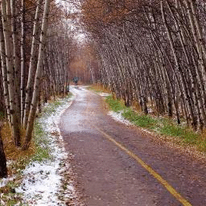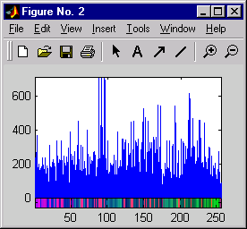
Figure: Sample Image and its Corresponding Histogram…
To view a histogram numerically one has to look at the colour map or the numeric representation of each bin.

Colour Map  (x-axis) |  |  |  | Number of Pixels per Bin  (y-axis)
H | S | V |  | Number of Pixels per Bin  (y-axis)
0.9922 | 0.9882 | 0.9961 |  | 106
0.9569 | 0.9569 | 0.9882 |  | 242
0.9725 | 0.9647 | 0.9765 |  | 273
0.9176 | 0.9137 | 0.9569 |  | 372
0.9098 | 0.8980 | 0.9176 |  | 185
0.9569 | 0.9255 | 0.9412 |  | 204
0.9020 | 0.8627 | 0.8980 |  | 135
0.9020 | 0.8431 | 0.8510 |  | 166
0.9098 | 0.8196 | 0.8078 |  | 179
0.8549 | 0.8510 | 0.8941 |  | 188
0.8235 | 0.8235 | 0.8941 |  | 241
0.8471 | 0.8353 | 0.8549 |  | 104
0.8353 | 0.7961 | 0.8392 |  | 198
. | . | . |  | .
. | . | . |  | .
. | . | . |  | .

Table: Colour Map and Number of pixels for the Previous Image.

As one can see from the colour map each row represents the colour of a bin. The row is composed of the three coordinates of the colour space. The first coordinate represents hue, the second saturation, and the third, value, thereby giving HSV. The percentages of each of these coordinates are what make up the colour of a bin. Also one can see the corresponding pixel numbers for each bin, which are denoted by the blue lines in the histogram.
Quantization in terms of colour histograms refers to the process of reducing the number of bins by taking colours that are very similar to each other and putting them in the same bin. By default the maximum number of bins one can obtain using the histogram function in MatLab is 256. For the purpose of saving time when trying to compare colour histograms, one can quantize the number of bins. Obviously quantization reduces the information regarding the content of images but as was mentioned this is the tradeoff when one wants to reduce processing time.

There are two types of colour histograms, Global colour histograms (GCHs) and Local colour histograms (LCHs). A GCH represents one whole image with a single colour histogram. An LCH divides an image into fixed blocks and takes the colour histogram of each of those blocks [7]. LCHs contain more information about an image but are computationally expensive when comparing images. “The GCH is the traditional method for colour based image retrieval. However, it does not include information concerning the colour distribution of the regions [7]” of an image. Thus when comparing GCHs one might not always get a proper result in terms of similarity of images.

7.2. Texture

7.2.1 Definition
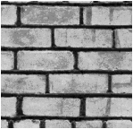
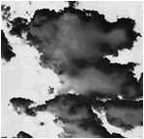
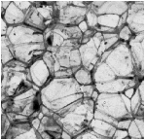
Texture is that innate property of all surfaces that describes visual patterns, each having properties of homogeneity. It contains important information about the structural arrangement of the surface, such as; clouds, leaves, bricks, fabric, etc. It also describes the relationship of the surface to the surrounding environment [2]. In short, it is a feature that describes the distinctive physical composition of a surface.
(a) Clouds
(b) Bricks
(c) Rocks

Texture properties include:
- Coarseness
- Contrast
- Directionality
- Line-likeness
- Regularity
- Roughness
Figure: Examples of Textures…

Texture is one of the most important defining features of an image. It is characterized by the spatial distribution of gray levels in a neighborhood [8]. In order to capture the spatial dependence of gray-level values, which contribute to the perception of texture, a two-dimensional dependence texture analysis matrix is taken into consideration. This two-dimensional matrix is obtained by decoding the image file; jpeg, bmp, etc.

7.2.2 Methods of Representation
There are three principal approaches used to describe texture; statistical, structural and spectral…
- Statistical techniques characterize textures using the statistical properties of the grey levels of the points/pixels comprising a surface image. Typically, these properties are computed using: the grey level co-occurrence matrix of the surface, or the wavelet transformation of the surface.
- Structural techniques characterize textures as being composed of simple primitive structures called “texels” (or texture elements). These are arranged regularly on a surface according to some surface arrangement rules.
- Spectral techniques are based on properties of the Fourier spectrum and describe global periodicity of the grey levels of a surface by identifying high-energy peaks in the Fourier spectrum [9].

For optimum classification purposes, what concern us are the statistical techniques of characterization… This is because it is these techniques that result in computing texture properties… The most popular statistical representations of texture are:
- Co-occurrence Matrix
- Tamura Texture
- Wavelet Transform

7.2.2.1 Co-occurrence Matrix
Originally proposed by R.M. Haralick, the co-occurrence matrix representation of texture features explores the grey level spatial dependence of texture [2]. A mathematical definition of the co-occurrence matrix is as follows [4]:
- Given a position operator P(i,j),
- let A be an n x n matrix
- whose element A[i][j] is the number of times that points with grey level (intensity) g[i] occur, in the position specified by P, relative to points with grey level g[j].
- Let C be the n x n matrix that is produced by dividing A with the total number of point pairs that satisfy P. C[i][j] is a measure of the joint probability that a pair of points satisfying P will have values g[i], g[j].
- C is called a co-occurrence matrix defined by P.
Examples for the operator P are: “i above j”, or “i one position to the right and two below j”, etc. [4]

This can also be illustrated as follows… Let t be a translation, then a co-occurrence matrix C_{t} of a region is defined for every grey-level (a, b) by [1]:
Here, C_{t}(a, b) is the number of site-couples, denoted by (s, s + t) that are separated by a translation vector t, with a being the grey-level of s, and b being the grey-level of s + t.

For example; with an 8 grey-level image representation and a vector t that considers only one neighbour, we would find [1]:
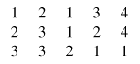
Figure: Image example

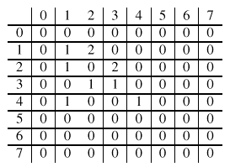
Figure: Classical Co-occurrence matrix

At first the co-occurrence matrix is constructed, based on the orientation and distance between image pixels. Then meaningful statistics are extracted from the matrix as the texture representation [2]. Haralick proposed the following texture features [10]:
- Angular Second Moment
- Contrast
- Correlation
- Variance
- Inverse Second Differential Moment
- Sum Average
- Sum Variance
- Sum Entropy
- Entropy
- Difference Variance
- Difference Entropy
- Measure of Correlation 1
- Measure of Correlation 2
- Local Mean

Hence, for each Haralick texture feature, we obtain a co-occurrence matrix. These co-occurrence matrices represent the spatial distribution and the dependence of the grey levels within a local area. Each (i,j) ^{th} entry in the matrices, represents the probability of going from one pixel with a grey level of 'i' to another with a grey level of 'j' under a predefined distance and angle. From these matrices, sets of statistical measures are computed, called feature vectors [11].

7.2.2.2 Tamura Texture
By observing psychological studies in the human visual perception, Tamura explored the texture representation using computational approximations to the three main texture features of: coarseness, contrast, and directionality [2, 12]. Each of these texture features are approximately computed using algorithms…

- Coarseness is the measure of granularity of an image [12], or average size of regions that have the same intensity [13].
- Contrast is the measure of vividness of the texture pattern. Therefore, the bigger the blocks that make up the image, the higher the contrast. It is affected by the use of varying black and white intensities [12].
- Directionality is the measure of directions of the grey values within the image [12].

7.2.2.3 Wavelet Transform
Textures can be modeled as quasi-periodic patterns with spatial/frequency representation. The wavelet transform transforms the image into a multi-scale representation with both spatial and frequency characteristics. This allows for effective multi-scale image analysis with lower computational cost [2]. According to this transformation, a function, which can represent an image, a curve, signal etc., can be described in terms of a coarse level description in addition to others with details that range from broad to narrow scales [11].

Unlike the usage of sine functions to represent signals in Fourier transforms, in wavelet transform, we use functions known as wavelets. Wavelets are finite in time, yet the average value of a wavelet is zero [2]. In a sense, a wavelet is a waveform that is bounded in both frequency and duration. While the Fourier transform converts a signal into a continuous series of sine waves, each of which is of constant frequency and amplitude and of infinite duration, most real-world signals (such as music or images) have a finite duration and abrupt changes in frequency. This accounts for the efficiency of wavelet transforms. This is because wavelet transforms convert a signal into a series of wavelets, which can be stored more efficiently due to finite time, and can be constructed with rough edges, thereby better approximating real-world signals [14].

Examples of wavelets are Coiflet, Morlet, Mexican Hat, Haar and Daubechies. Of these, Haar is the simplest and most widely used, while Daubechies have fractal structures and are vital for current wavelet applications [2]. These two are outlined below:

Haar Wavelet
The Haar wavelet family is defined as [2]:
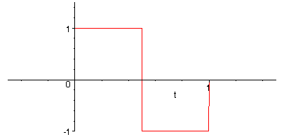
Figure: Haar Wavelet Example…

[For more information, see Appendix - A: Recommended Readings]

Daubechies Wavelet
The Daubechies wavelet family is defined as [2]:
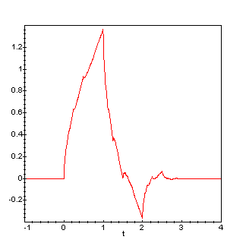

Figure: Daubechies Wavelet Example

[For more information, see Appendix - A: Recommended Readings]

Later in this report, in the Project Details, further details regarding the wavelet transform will be touched upon.

7.3 Shape

7.3.1 Definition
Shape may be defined as the characteristic surface configuration of an object; an outline or contour. It permits an object to be distinguished from its surroundings by its outline [15]. Shape representations can be generally divided into two categories [2]:
- Boundary-based, and
- Region-based.
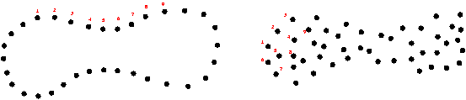

Figure: Boundary-based & Region-based… [16]

Boundary-based shape representation only uses the outer boundary of the shape. This is done by describing the considered region using its external characteristics; i.e., the pixels along the object boundary. Region-based shape representation uses the entire shape region by describing the considered region using its internal characteristics; i.e., the pixels contained in that region [17].

7.3.2 Methods of Representation
For representing shape features mathematically, we have [16]:
Boundary-based:
- Polygonal Models, boundary partitioning
- Fourier Descriptors
- Splines, higher order constructs
- Curvature Models
Region-based:
- Superquadrics
- Fourier Descriptors
- Implicit Polynomials
- Blum's skeletons

The most successful representations for shape categories are Fourier Descriptor and Moment Invariants [2]:
- The main idea of Fourier Descriptor is to use the Fourier transformed boundary as the shape feature.
- The main idea of Moment invariants is to use region-based moments, which are invariant to transformations as the shape feature.

8. Project Details

8.1 Colour

8.1.1 Quadratic Distance Metric
The equation we used in deriving the distance between two colour histograms is the quadratic distance metric:
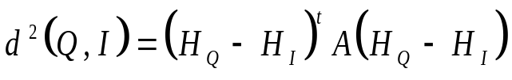
The equation consists of three terms. The derivation of each of these terms will be explained in the following sections. The first term consists of the difference between two colour histograms; or more precisely the difference in the number of pixels in each bin. This term is obviously a vector since it consists of one row. The number of columns in this vector is the number of bins in a histogram. The third term is the transpose of that vector. The middle term is the similarity matrix. The final result d represents the colour distance between two images. The closer the distance is to zero the closer the images are in colour similarity. The further the distance from zero the less similar the images are in colour similarity.

8.1.2 Histograms
We used Global colour histograms in extracting the colour features of images. In analyzing the histograms there were a few issues that had to be dealt with. First there was the issue of how much we would quantize the number of bins in a histogram. By default the number of bins represented in an image's colour histogram using the imhist() function in MatLab is 256. Meaning that in our calculations of similarity matrix and histogram difference, the processing would be computationally expensive. Initially we decided to quantize the number of bins to 20. This means that colours that are distinct yet similar are assigned to the same bin reducing the number of bins from 256 to 20. This obviously decreases the information content of images, but decreases the time in calculating the colour distance between two histograms. On the other hand keeping the number of bins at 256 gives a more accurate result in terms of colour distance. Later on we went back to 256 bins due to some inconsistencies obtained in the colour distances between images. This had nothing to do with quantizing the image but rather with the types of images we where using which will be further elaborated later on in the Results section.
The second issue was in which colour space would we present our colour map. Should it be RGB or HSV? This was solved right away when we found that QBIC's similarity matrix equation was using the HSV colour space in its calculation. There hasn't been any evidence to show which colour space generates the best retrieval results, thus the use of this colour space did not restrict us an anyway.

8.1.3 Similarity Matrix
As can be seen from the colour histograms of two images Q and I in the figure below, the colour patterns observed in the colour bar are totally different. This is further confirmed when one sees the respective colour maps in the following table…
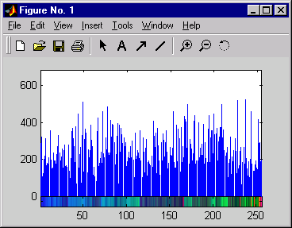
(a) Image Q

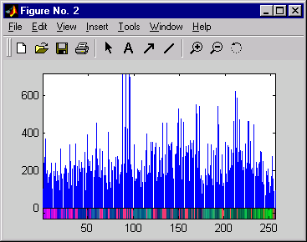
(a) Image I
Figure: Colour Histograms of two images.

Colour Map of image Q |  |  |  | Colour Map of image I
0.9608 | 0.8980 | 0.7843 |  | 0.9922 | 0.9882 | 0.9961
0.9373 | 0.9059 | 0.8235 |  | 0.9569 | 0.9569 | 0.9882
0.9098 | 0.8510 | 0.7765 |  | 0.9725 | 0.9647 | 0.9765
0.9255 | 0.8588 | 0.8039 |  | 0.9176 | 0.9137 | 0.9569
0.8627 | 0.8275 | 0.7961 |  | 0.9098 | 0.8980 | 0.9176
0.9098 | 0.8431 | 0.7216 |  | 0.9569 | 0.9255 | 0.9412
0.9137 | 0.8392 | 0.6627 |  | 0.9020 | 0.8627 | 0.8980
0.9059 | 0.7882 | 0.6510 |  | 0.9020 | 0.8431 | 0.8510
0.9451 | 0.8275 | 0.6824 |  | 0.9098 | 0.8196 | 0.8078
0.9569 | 0.7882 | 0.5922 |  | 0.8549 | 0.8510 | 0.8941
0.9137 | 0.7765 | 0.5961 |  | 0.8235 | 0.8235 | 0.8941
0.9412 | 0.7961 | 0.5569 |  | 0.8471 | 0.8353 | 0.8549
0.8471 | 0.7843 | 0.7176 |  | 0.8353 | 0.7961 | 0.8392
0.8275 | 0.7843 | 0.6745 |  | 0.8431 | 0.7804 | 0.7843
0.9020 | 0.8392 | 0.6667 |  | 0.7961 | 0.7804 | 0.8353
0.8980 | 0.7333 | 0.5843 |  | 0.7882 | 0.7725 | 0.7882
0.9020 | 0.7216 | 0.5333 |  | 0.8235 | 0.8314 | 0.8118
. | . | . |  | . | . | .
. | . | . |  | . | . | .
. | . | . |  | . | . | .

Table: Colour Maps of two images.

A simple distance metric involving the subtraction of the number of pixels in the 1st bin of one histogram from the 1st bin of another histogram and so on is not adequate. This metric is referred to as a Minkowski-Form Distance Metric, shown below, which only compares the “same bins between colour histograms [3]”.

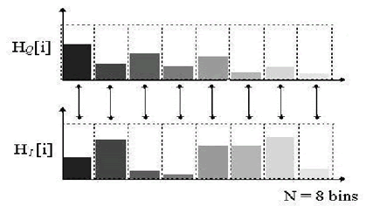

Figure: Minkowski Distance Approach…

This is the main reason for using the quadratic distance metric. More precisely it is the middle term of the equation or similarity matrix A that helps us overcome the problem of different colour maps. The similarity matrix is obtained through a complex algorithm:
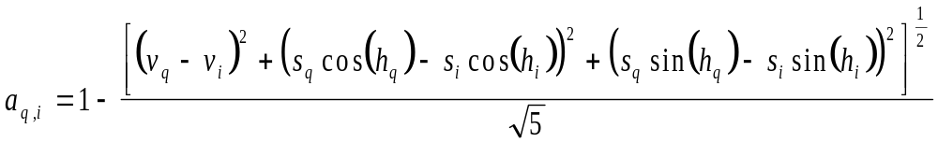
which basically compares one colour bin of H_{Q} with all those of H_{I} to try and find out which colour bin is the most similar, as shown below:

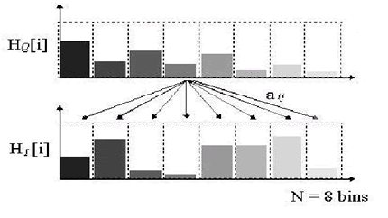

Figure: Quadratic Distance Approach…

This is continued until we have compared all the colour bins of H_{Q}. In doing so we get an N x N matrix, N representing the number of bins. What indicates whether the colour patterns of two histograms are similar is the diagonal of the matrix, shown below. If the diagonal entirely consists of ones then the colour patterns are identical. The further the numbers in the diagonal are from one, the less similar the colour patterns are. Thus the problem of comparing totally unrelated bins is solved.

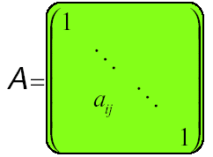

Figure: Similarity Matrix A, with a diagonal of ones…[3]

8.1.4 Results

After obtaining all the necessary terms, similarity matrix, and colour histogram differences, for a number of images in our database, we implemented the results in the final equation, Quadratic Distance Metric. Surprisingly a number of inconsistencies kept appearing in terms of the colour distances between certain images. Images that where totally unrelated had colour distances smaller than those that where very similar. An example of this can be seen with the following three images: a mosque, a hockey game, and another picture of the same hockey game, as seen below…

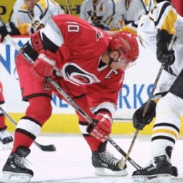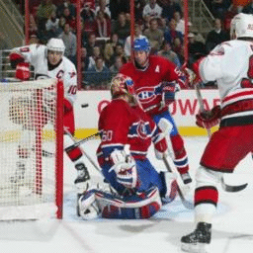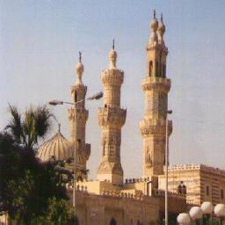
(a) faceoff3 (b) faceoff4 (c) mosque

Figure: Tested Images…

As can be seen from the following table, the results are not consistent with how the images look to the human eye.

Images | Colour distance between image histograms
faceoff3 vs faceoff4 | 10.77
faceoff3 vs mosque | 9.99

Table: Colour Distances for Compressed Images…

This was done again and again with a number of images, and resulted in the same inconsistencies. What turned out to be the cause of all this, were the type of images we were using. At first we thought the only thing that could give inconsistent results like this was comparing images of different sizes, but we had resized all the images in our database to 256x256 before testing our algorithm. The images we had in our database where all 24-bit JPEGs. The problem with JPEG images is that they are compressed and the compression algorithm seems to affect the way the histograms are derived. We found this out by converting some of the images in our database to 8-bit uncompressed bit maps. The same images that where tested in JPEG format where tested again as BMPs. What resulted was consistent with how the images looked to the human eye. Images that looked similar gave small colour distances compared to those that looked very different. This can be seen in the following table, which shows the same images as those in the previous table but in BMP format.

Images | Colour distance between image histograms
faceoff3 vs faceoff4 | 4.39
faceoff3 vs mosque | 6.10

Table: Colour Distances for Uncompressed Images…

In realizing that our error was due to image format, we decided to convert all our images to uncompressed BMPs. This obviously is not consistent with full CBIR systems available in the market, which take any type of image as a query in any format, but for the purposes of this project we did not want to delve into compression issues.

In converting all of our images to 8-bit uncompressed BMPs there was a slight change in the way we dealt with their respective colour maps. What we previously did was index an image before using the imhist function. What indexing does is quantize the colour map by letting the user specify the number of bins. This obviously reduces the processing time in terms of calculating colour distances since you don't have 256 bins to compare. When loading 8-bit uncompressed images into a variable, MatLab does not let you quantize their colour maps. It gives you an error when you try to index them. Thus we where forced to stick to the default value of 256 bins for all our colour histograms.

8.2 Texture

8.2.1 Pyramid-Structured Wavelet Transform

We used a method called the pyramid-structured wavelet transform for texture classification. Its name comes from the fact that it recursively decomposes sub signals in the low frequency channels. It is mostly significant for textures with dominant frequency channels. For this reason, it is mostly suitable for signals consisting of components with information concentrated in lower frequency channels [2]. Due to the innate image properties that allows for most information to exist in lower sub-bands, the pyramid-structured wavelet transform is highly sufficient.

Using the pyramid-structured wavelet transform, the texture image is decomposed into four sub images, in low-low, low-high, high-low and high-high sub-bands. At this point, the energy level of each sub-band is calculated [see energy level algorithm in next section (8.2.2)]. This is first level decomposition. Using the low-low sub-band for further decomposition, we reached fifth level decomposition, for our project. The reason for this is the basic assumption that the energy of an image is concentrated in the low-low band. For this reason the wavelet function used is the Daubechies wavelet.

Figure: Pyramid-Structured Wavelet Transform.

8.2.2 Energy Level
Energy Level Algorithm:
1. Decompose the image into four sub-images
2. Calculate the energy of all decomposed images at the same scale, using [2]:
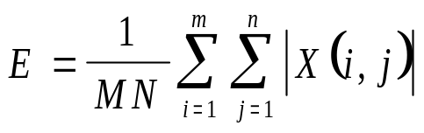
where M and N are the dimensions of the image, and X is the intensity of the pixel located at row i and column j in the image map.
3. Repeat from step 1 for the low-low sub-band image, until index ind is equal to 5. Increment ind.
Using the above algorithm, the energy levels of the sub-bands were calculated, and further decomposition of the low-low sub-band image. This is repeated five times, to reach fifth level decomposition. These energy level values are stored to be used in the Euclidean distance algorithm.

8.2.3 Euclidean Distance
Euclidean Distance Algorithm:
- Decompose query image.
- Get the energies of the first dominant k channels.
- For image i in the database obtain the k energies.
- Calculate the Euclidean distance between the two sets of energies, using [2]:
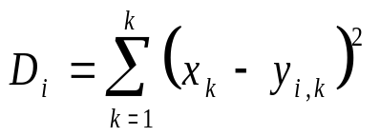
- Increment i. Repeat from step 3.
Using the above algorithm, the query image is searched for in the image database. The Euclidean distance is calculated between the query image and every image in the database. This process is repeated until all the images in the database have been compared with the query image. Upon completion of the Euclidean distance algorithm, we have an array of Euclidean distances, which is then sorted. The five topmost images are then displayed as a result of the texture search.

8.3 GUI
The Graphical User Interface was constructed using MatLab GUIDE or Graphical User Interface Design Environment. Using the layout tools provided by GUIDE, we designed the following graphical user interface figure (aDemo.fig) for our CBIR application:
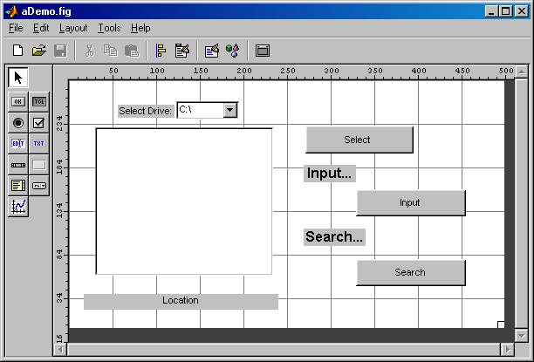
Figure: GUI Design, aDemo.fig…

In addition to the above outlined design, we also designed a simple menu structure, using the Menu Editor, as shown below:
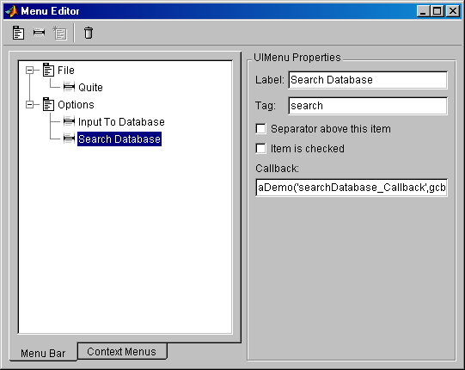
Figure: Menu Editor specification for the menu…

The above design yields the following application window on run time:
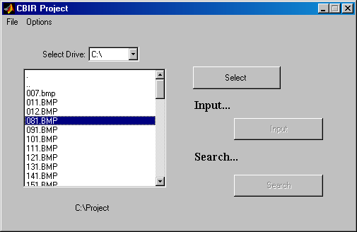
Figure: Application window at runtime…

The handlers for clicking on the buttons are coded using MatLab code to perform the necessary operations. [These are available in Appendix - C: MatLab Code.]

8.4 Database
The image database that we used in our project contains sixty 8-bit uncompressed bit maps BMPs that have been randomly selected from the World Wide Web. The following figure depicts a sample of images in the database:

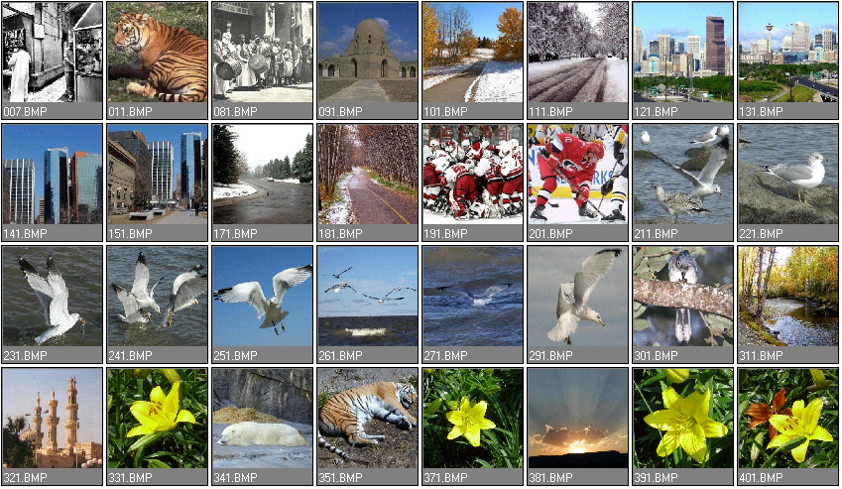
Figure: Image Database…

8.5 Example
To demonstrate the project application, we implemented the following example:
- We started the application by typing aDemo and pressing return in the MatLab Command Window. The application window started.
- In the application window, we selected the Options menu, and selected Search Database. This enabled the browsing window, to browse to a BMP file.
- Upon highlighting a BMP file, the select button became enabled. Note: Only 8-bit uncompressed BMPs are suitable for this application. In this example, we selected 371.bmp.
- The highlighted BMP is then selected by pressing the Select button.
- Next, pressing the Search button started the search.
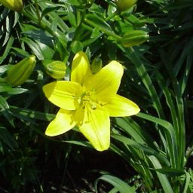
Figure: The query image: 371.bmp…

8.5.1 Colour Extraction & Matching
Using the colour feature extraction algorithm described above, where the histograms of the query image and the images in the database are compared using the Quadratic Distance Metric, we obtained the following top 10 results:
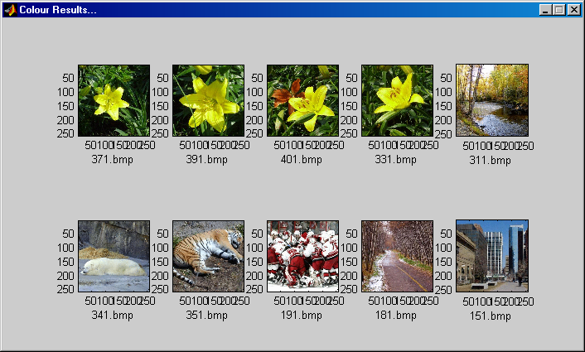
Figure: Colour Results for the searching for 371.bmp

The above results are sorted according to the quadratic distance… These are shown below:
File Name | Colour Distance
371.bmp | 0
391.bmp | 3.3804
401.bmp | 4.3435
331.bmp | 5.0800
311.bmp | 5.9940
341.bmp | 6.6100
351.bmp | 6.9638
191.bmp | 7.0813
181.bmp | 7.1060
151.bmp | 7.1958

Table: Colour distance between query and results…

8.5.2 Texture Extraction & Matching
Using the texture feature extraction algorithm described above, where the energies of the query image and the colour result images’ sub-bands are compared using the Euclidean Distance Metric, we obtained the following top 4 results:
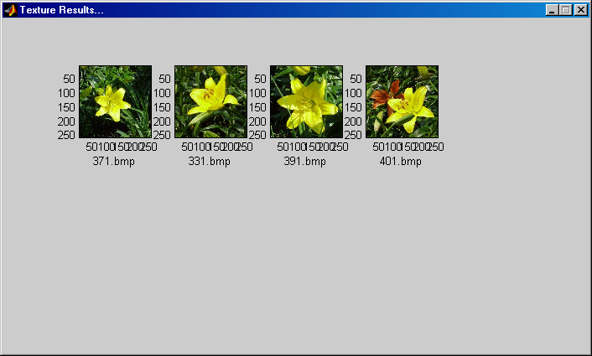
Figure: Texture Results for the searching for 371.bmp

The above results are sorted according to the Euclidean distance… These are shown below:
File Name | Euclidean Distance
371.bmp | 0
331.bmp | 1.1449
391.bmp | 2.4609
401.bmp | 2.6926

Table: Euclidean distance between query and results…

By observing the images in our database, we can actually say that the above results represent the closest matches to the query image chosen.

9. Conclusions
The dramatic rise in the sizes of images databases has stirred the development of effective and efficient retrieval systems. The development of these systems started with retrieving images using textual connotations but later introduced image retrieval based on content. This came to be known as CBIR or Content Based Image Retrieval. Systems using CBIR retrieve images based on visual features such as colour, texture and shape, as opposed to depending on image descriptions or textual indexing. In this project, we have researched various modes of representing and retrieving the image properties of colour, texture and shape. Due to lack of time, we were only able to fully construct an application that retrieved image matches based on colour and texture only.

The application performs a simple colour-based search in an image database for an input query image, using colour histograms. It then compares the colour histograms of different images using the Quadratic Distance Equation. Further enhancing the search, the application performs a texture-based search in the colour results, using wavelet decomposition and energy level calculation. It then compares the texture features obtained using the Euclidean Distance Equation. A more detailed step would further enhance these texture results, using a shape-based search.

CBIR is still a developing science. As image compression, digital image processing, and image feature extraction techniques become more developed, CBIR maintains a steady pace of development in the research field. Furthermore, the development of powerful processing power, and faster and cheaper memories contribute heavily to CBIR development. This development promises an immense range of future applications using CBIR.

10. References

- Barbeau Jerome, Vignes-Lebbe Regine, and Stamon Georges, “A Signature based on Delaunay Graph and Co-occurrence Matrix,” Laboratoire Informatique et Systematique, Universiyt of Paris, Paris, France, July 2002, Found at:
http://www.math-info.univ-paris5.fr/sip-lab/barbeau/barbeau.pdf
- Sharmin Siddique, “A Wavelet Based Technique for Analysis and Classification of Texture Images,” Carleton University, Ottawa, Canada, Proj. Rep. 70.593, April 2002.
- Thomas Seidl and Hans-Peter Kriegel, “Efficient User-Adaptable Similarity Search in Large Multimedia Databases,” in Proceedings of the 23rd International Conference on Very Large Data Bases VLDB’97, Athens, Greece, August 1997, Found at:
http://www.vldb.org/conf/1997/P506.PDF
- FOLDOC, Free On-Line Dictionary Of Computing, “cooccurrence matrix,” May 1995, [Online Document], Available at:
http://foldoc.doc.ic.ac.uk/foldoc/foldoc.cgi?cooccurrence+matrix
- Colin C. Venteres and Dr. Matthew Cooper, “A Review of Content-Based Image Retrieval Systems”, [Online Document], Available at:
http://www.jtap.ac.uk/reports/htm/jtap-054.html
- Linda G. Shapiro, and George C. Stockman, Computer Vision, Prentice Hall, 2001.
- Shengjiu Wang, “A Robust CBIR Approach Using Local Color Histograms,” Department of Computer Science, University of Alberta, Edmonton, Alberta, Canada, Tech. Rep. TR 01-13, October 2001, Found at:
http://citeseer.nj.nec.com/wang01robust.html
- R. Jain, R. Kasturi, and B. G. Schunck, Machine Vision, McGraw Hill International Editions, 1995.
- FOLDOC, Free On-Line Dictionary Of Computing, “texture,” May 1995, [Online Document], Available at:
http://foldoc.doc.ic.ac.uk/foldoc/foldoc.cgi?query=texture
- “Texture,” class notes for Computerized Image Analysis MN2, Centre for Image Analysis, Uppsala, Sweden, Winter 2002, Found at:
http://www.cb.uu.se/~ingela/Teaching/ImageAnalysis/Texture2002.pdf
- G. D. Magoulas, S. A. Karkanis, D. A. Karras and M. N. Vrahatis, “Comparison Study of Textural Descriptors for Training Neural Network Classifiers”, in Proceedings of the 3rd IEEE-IMACS World Multi-conference on Circuits, Systems, Communications and Computers, vol. 1, 6221-6226, Athens, Greece, July 1999, Found at:
http://www.brunel.ac.uk/~csstgdm/622.pdf
- Pravi Techasith, “Image Search Engine,” Imperial College, London, UK, Proj. Rep., July 2002, Found at:
http://km.doc.ic.ac.uk/pr-p.techasith-2002/Docs/OSE.doc
- Bjorn Johansson, “QBIC (Query By Image Content)”, November 2002, [Online Document], Available at:
http://www.isy.liu.se/cvl/Projects/VISIT-bjojo/survey/surveyonCBIR/node26.html
- FOLDOC, Free On-Line Dictionary Of Computing, “wavelet,” May 1995, [Online Document], Available at:
http://foldoc.doc.ic.ac.uk/foldoc/foldoc.cgi?query=wavelet
- Lexico Publishing Group, LLC, “shape”, [Online Document], Available at:
http://dictionary.reference.com/search?q=shape
- Benjamin B. Kimia, “Symmetry-Based Shape Representations,” Laboratory for Engineering Man/Machine Systems (LEMS), IBM, Watson Research Center, October 1999, Found at:
http://www.lems.brown.edu/vision/Presentations/Kimia/IBM-Oct-99/talk.html
- Marinette Bouet, Ali Khenchaf, and Henri Briand, “Shape Representation for Image Retrieval”, 1999, [Online Document], Available at:
http://www.kom.e-technik.tu-darmstadt.de/acmmm99/ep/marinette/

11. Appendices

Appendix - A: Recommended Readings

CBIR Systems
http://www.jtap.ac.uk/reports/htm/jtap-054.html

Haar Wavelet
http://amath.colorado.edu/courses/4720/2000Spr/Labs/Haar/haar.html

Daubechies Wavelet
http://amath.colorado.edu/courses/4720/2000Spr/Labs/DB/db.html

Appendix - B: Glossary

CBIR | (Content Based Image Retrieval)- The process of retrieving images based on visual features such as texture and colour.
Colour distance | The degree of similarity between two colour histograms represented by a numerical distance. The closer the distance is to zero the more similar two images are in terms of colour. The further away the distance is from zero, the less similar.
Colour histogram | a histogram that represents the colour information of an image. The x-axis represents all the different colours found in the image. Each specific colour is referred to as a bin. The y-axis represents the number of pixels in each bin.
Colour space | the three dimensional space in which colour is defined.
Euclidean distance | equation used to compare average intensities of pixels.
Global colour histogram | the colour histogram of the whole image.
HSV | Hue Saturation Value colour space.
Local colour histogram | the colour histogram of a subsection of an image.
Quadratic metric | equation used to calculate the colour distance. Consists of three terms, colour histogram difference, transpose of colour histogram difference, and similarity matrix.
Quantization | Reducing the number of colour bins in a colour map by taking colours that are very similar to each other and putting them in the same bin.
QBIC | CBIR system developed by IBM.
RGB | Red Green Blue colour space
Similarity matrix | Matrix that denotes the similarity between two sets of data. This is identified by the diagonal of the matrix. The closer the sets of data, the closer the diagonal is to one. The farther the sets of data, the farther the diagonal is from one.

Appendix - C: MatLab Code

aDemo.m
function varargout = Demo(varargin)

% ------------------------------------------------------------
% DEMO Application M-file for Demo.fig
% DEMO, by itself, creates a new DEMO or raises the existing
% singleton*.
%
% H = DEMO returns the handle to a new DEMO or the handle to
% the existing singleton*.
%
% DEMO('CALLBACK',hObject,eventData,handles,...) calls the local
% function named CALLBACK in DEMO.M with the given input arguments.
%
% DEMO('Property','Value',...) creates a new DEMO or raises the
% existing singleton*. Starting from the left, property value pairs are
% applied to the GUI before Demo_OpeningFunction gets called. An
% unrecognized property name or invalid value makes property application
% stop. All inputs are passed to Demo_OpeningFcn via varargin.
%
% *See GUI Options - GUI allows only one instance to run (singleton).
%
% See also: GUIDE, GUIDATA, GUIHANDLES

% Edit the above text to modify the response to help Demo

% Last Modified by GUIDE v2.5 21-Oct-2002 03:11:52
% ------------------------------------------------------------

% ------------------------------------------------------------
% Begin initialization code - DO NOT EDIT
gui_Singleton = 1;
gui_State = struct('gui_Name', mfilename, ...
'gui_Singleton', gui_Singleton, ...
'gui_OpeningFcn', @Demo_OpeningFcn, ...
'gui_OutputFcn', @Demo_OutputFcn, ...
'gui_LayoutFcn', [], ...
'gui_Callback', []);

if nargin == 0 % LAUNCH GUI
initial_dir = pwd;

% Open FIG-file
fig = openfig(mfilename,'reuse'); % Generate a structure of handles to pass to callbacks, and store it.
handles = guihandles(fig);
guidata(fig, handles);

%disp('populate1!!');

% Populate the listbox
load_listbox(initial_dir,handles)

% Return figure handle as first output argument
if nargout > 0
varargout{1} = fig;
end

elseif ischar(varargin{1}) % INVOKE NAMED SUBFUNCTION OR CALLBACK

try
[varargout{1:nargout}] = feval(varargin{:}); % FEVAL switchyard
catch
disp(lasterr);
end

end

% End initialization code - DO NOT EDIT
% ------------------------------------------------------------

% ------------------------------------------------------------
% Executes just before Demo is made visible.
% ------------------------------------------------------------
function Demo_OpeningFcn(hObject, eventdata, handles, varargin)
% This function has no output args, see OutputFcn.
% hObject handle to figure
% eventdata reserved - to be defined in a future version of MATLAB
% handles structure with handles and user data (see GUIDATA)
% varargin command line arguments to Demo (see VARARGIN)

% Choose default command line output for Demo...
handles.output = hObject;

% Initialize the options...
handles.option = 'input';

% Update handles structure...
guidata(hObject, handles);

% ------------------------------------------------------------

% ------------------------------------------------------------
% Outputs from this function are returned to the command line.
% ------------------------------------------------------------
function varargout = Demo_OutputFcn(hObject, eventdata, handles)
% varargout cell array for returning output args (see VARARGOUT);
% hObject handle to figure
% eventdata reserved - to be defined in a future version of MATLAB
% handles structure with handles and user data (see GUIDATA)

% Get default command line output from handles structure
varargout{1} = handles.output;
% ------------------------------------------------------------

% ------------------------------------------------------------
% Callback for list box - open .fig with guide, otherwise use open
% ------------------------------------------------------------
function varargout = listbox1_Callback(h, eventdata, handles)
% hObject handle to listbox1 (see GCBO)
% eventdata reserved - to be defined in a future version of MATLAB
% handles structure with handles and user data (see GUIDATA)

% Hints: contents = get(hObject,'String') returns listbox1 contents as cell array
% contents{get(hObject,'Value')} returns selected item from listbox1

mouse_event = get(handles.figure1,'SelectionType');
index_selected = get(handles.listbox1,'Value');
file_list = get(handles.listbox1,'String');
filename = file_list{index_selected};

if strcmp(mouse_event,'normal')
if ~handles.is_dir(handles.sorted_index(index_selected))
[newpath, name, ext, ver] = fileparts(filename);
switch ext
case '.BMP'
set(handles.selectButton, 'Enable', 'On');
case '.bmp'
set(handles.selectButton, 'Enable', 'On');
otherwise
set(handles.selectButton, 'Enable', 'Off');
end
end
end

if strcmp(mouse_event,'open')
if handles.is_dir(handles.sorted_index(index_selected))
cd (filename)
load_listbox(pwd,handles)
end
end

% ------------------------------------------------------------

% ------------------------------------------------------------
% Read the current directory and sort the names
% ------------------------------------------------------------
function load_listbox(dir_path,handles)
cd (dir_path)
dir_struct = dir(dir_path);
[sorted_names,sorted_index] = sortrows({dir_struct.name}');
handles.file_names = sorted_names;
handles.is_dir = [dir_struct.isdir];
handles.sorted_index = [sorted_index];
guidata(handles.figure1,handles)
set(handles.listbox1,'String',handles.file_names,...
'Value',1)
set(handles.text1,'String',pwd)

% ------------------------------------------------------------

% ------------------------------------------------------------
% Executes during object creation, after setting all properties.
% ------------------------------------------------------------
function listbox1_CreateFcn(hObject, eventdata, handles)
% hObject handle to listbox1 (see GCBO)
% eventdata reserved - to be defined in a future version of MATLAB
% handles empty - handles not created until after all CreateFcns called

% Hint: listbox controls usually have a white background, change
% 'usewhitebg' to 0 to use default. See ISPC and COMPUTER.
usewhitebg = 1;
if usewhitebg
set(hObject,'BackgroundColor','white');
else
set(hObject,'BackgroundColor',get(0,'defaultUicontrolBackgroundColor'));
end

% ------------------------------------------------------------

% ------------------------------------------------------------
% Executes during object creation, after setting all properties.
% ------------------------------------------------------------
function popupmenu_CreateFcn(hObject, eventdata, handles)
% hObject handle to popupmenu (see GCBO)
% eventdata reserved - to be defined in a future version of MATLAB
% handles empty - handles not created until after all CreateFcns called

% Hint: popupmenu controls usually have a white background on Windows.
% See ISPC and COMPUTER.
if ispc
set(hObject,'BackgroundColor','white');
else
set(hObject,'BackgroundColor',get(0,'defaultUicontrolBackgroundColor'));
end

% ------------------------------------------------------------

% ------------------------------------------------------------
% Executes on selection change in popupmenu.
% ------------------------------------------------------------
function popupmenu_Callback(hObject, eventdata, handles)
% hObject handle to popupmenu (see GCBO)
% eventdata reserved - to be defined in a future version of MATLAB
% handles structure with handles and user data (see GUIDATA)

% Hints: contents = get(hObject,'String') returns popupmenu contents as cell array
% contents{get(hObject,'Value')} returns selected item from popupmenu

val = get(hObject,'Value');
str = get(hObject, 'String');
cd(str{val});

load_listbox(pwd, handles)

% ------------------------------------------------------------

% ------------------------------------------------------------
% Executes on selection of 'Quite' from the menubar.
% ------------------------------------------------------------
function quite_Callback(hObject, eventdata, handles)
% hObject handle to CloseMenuItem (see GCBO)
% eventdata reserved - to be defined in a future version of MATLAB
% handles structure with handles and user data (see GUIDATA)

selection = questdlg('Are you sure you want to quite?',...
['Close ' get(handles.figure1,'Name') '...'],...
'Yes','No','Yes');
if strcmp(selection,'No')
return;
end

delete(handles.figure1)

% ------------------------------------------------------------

% ------------------------------------------------------------
% Executes on selection of 'Input To Database' from the menubar.
% ------------------------------------------------------------
function inputDatabase_Callback(hObject, eventdata, handles)
% hObject handle to CloseMenuItem (see GCBO)
% eventdata reserved - to be defined in a future version of MATLAB
% handles structure with handles and user data (see GUIDATA)

% Some code to input the selected image to the database...

set(handles.input, 'Checked', 'On');
set(handles.search, 'Checked', 'Off');

set(handles.listbox1, 'Enable', 'On');
set(handles.text1, 'Enable', 'On');
set(handles.popupmenu, 'Enable', 'On');

handles.option = 'input'; % This means that the option is to "input to database"...

guidata(hObject, handles)

% ------------------------------------------------------------

% ------------------------------------------------------------
% Executes on selection of 'Search Database' from the menubar.
% ------------------------------------------------------------
function searchDatabase_Callback(hObject, eventdata, handles)
% hObject handle to CloseMenuItem (see GCBO)
% eventdata reserved - to be defined in a future version of MATLAB
% handles structure with handles and user data (see GUIDATA)

% Some code to search the database for the selected image...

set(handles.input, 'Checked', 'Off');
set(handles.search, 'Checked', 'On');

set(handles.listbox1, 'Enable', 'On');
set(handles.text1, 'Enable', 'On');
set(handles.popupmenu, 'Enable', 'On');

handles.option = 'search'; % This means that the option is to "search database"...

guidata(hObject, handles)

% ------------------------------------------------------------

% ------------------------------------------------------------
% Executes on button press in selectbutton.
% ------------------------------------------------------------
function selectButton_Callback(hObject, eventdata, handles)
% hObject handle to selectButton (see GCBO)
% eventdata reserved - to be defined in a future version of MATLAB
% handles structure with handles and user data (see GUIDATA)

index_selected = get(handles.listbox1,'Value');
file_list = get(handles.listbox1,'String');
filename = file_list{index_selected};

[newpath,name,ext,ver] = fileparts(filename);

handles.filename = strcat(name,ext);

[handles.queryx, handles.querymap] = imread(filename); %read the image file.
cd('C:\Project');

figure

imshow(handles.queryx, handles.querymap); %This displays the image.

% Obtain HSV format of the image...
handles.queryhsv = rgb2hsv(handles.querymap);

guidata(hObject,handles)

set(handles.selectButton, 'Enable', 'Off');

set(handles.listbox1, 'Enable', 'Off');
set(handles.text1, 'Enable', 'Off');
set(handles.popupmenu, 'Enable', 'Off');

set(handles.input, 'Enable', 'Off');
set(handles.search, 'Enable', 'Off');

% handles.option

switch handles.option
case 'input'
set(handles.inputButton, 'Enable', 'On');
case 'search'
set(handles.searchButton, 'Enable', 'On');
end

% ------------------------------------------------------------

% ------------------------------------------------------------
% Executes on button press in inputButton.
% ------------------------------------------------------------
function inputButton_Callback(hObject, eventdata, handles)
% hObject handle to transform1button (see GCBO)
% eventdata reserved - to be defined in a future version of MATLAB
% handles structure with handles and user data (see GUIDATA)

set(handles.inputButton, 'Enable', 'Off');

% Open database txt file... for reading...
fid = fopen('database.txt');

exists = 0;

while 1
tline = fgetl(fid);
if ~ischar(tline), break, end % Meaning: End of File...
if (strcmp(tline, handles.filename))
exists = 1;
break;
end

end

fclose(fid);

if ~exists
fid = fopen('database.txt', 'a');
fprintf(fid,'%s\r',handles.filename);
fclose(fid);
end

guidata(hObject, handles)

msgbox('Database updated with file name...', 'Success...');

set(handles.input, 'Checked', 'Off');
set(handles.search, 'Checked', 'Off');
set(handles.input, 'Enable', 'On');
set(handles.search, 'Enable', 'On');

% ------------------------------------------------------------

% ------------------------------------------------------------
% Executes on button press in searchButton.
% ------------------------------------------------------------
function searchButton_Callback(hObject, eventdata, handles)
% hObject handle to transform2button (see GCBO)
% eventdata reserved - to be defined in a future version of MATLAB
% handles structure with handles and user data (see GUIDATA)

set(handles.searchButton, 'Enable', 'Off');

% Colour search...

% Open database txt file... for reading...
fid = fopen('database.txt');

resultValues = []; % Results matrix...
resultNames = {};
i = 1; % Indices...
j = 1;

while 1
imagename = fgetl(fid);
if ~ischar(imagename), break, end % Meaning: End of File...

[X, RGBmap] = imread(imagename);
HSVmap = rgb2hsv(RGBmap);

D = quadratic(handles.queryx, handles.querymap, X, HSVmap);
resultValues(i) = D;
resultNames(j) = {imagename};
i = i + 1;
j = j + 1;
end

fclose(fid);

% Sorting colour results...

[sortedValues, index] = sort(resultValues); % Sorted results... the vector index
% is used to find the resulting files.

fid = fopen('colourResults.txt', 'w+'); % Create a file, over-write old ones.

for i = 1:10 % Store top 10 matches...
tempstr = char(resultNames(index(i)));
fprintf(fid, '%s\r', tempstr);

disp(resultNames(index(i)));
disp(sortedValues(i));
disp(' ');
end

fclose(fid);

%return;

disp('Colour part done...');
disp('Colour results saved...');
disp('');

displayResults('colourResults.txt', 'Colour Results...');

disp('Texture part starting...');

% Texture search...

queryEnergies = obtainEnergies(handles.queryx, 6); % Obtain top 6 energies of the image.

% Open colourResults txt file... for reading...
fid = fopen('colourResults.txt');

fresultValues = []; % Results matrix...
fresultNames = {};
i = 1; % Indices...
j = 1;

while 1
imagename = fgetl(fid);
if ~ischar(imagename), break, end % Meaning: End of File...

[X, RGBmap] = imread(imagename);

imageEnergies = obtainEnergies(X, 6);

E = euclideanDistance(queryEnergies, imageEnergies);

fresultValues(i) = E;
fresultNames(j) = {imagename};
i = i + 1;
j = j + 1;
end

fclose(fid);
disp('Texture results obtained...');

% Sorting final results...

[sortedValues, index] = sort(fresultValues); % Sorted results... the vector index
% is used to find the resulting files.

fid = fopen('textureResults.txt', 'w+'); % Create a file, over-write old ones.

for i = 1:4 % Store top 5 matches...
imagename = char(fresultNames(index(i)));
fprintf(fid, '%s\r', imagename);

disp(imagename);
disp(sortedValues(i));
disp(' ');

end

fclose(fid);
disp('Texture results saved...');

displayResults('textureResults.txt', 'Texture Results...');

guidata(hObject,handles)

set(handles.input, 'Checked', 'Off');
set(handles.search, 'Checked', 'Off');
set(handles.input, 'Enable', 'On');
set(handles.search, 'Enable', 'On');

% ------------------------------------------------------------

decompose.m

% Works to decompose the passed image matrix...

% ------------------------------------------------------------
% Executes on being called, with input image matrix.
% ------------------------------------------------------------
function [Tl, Tr, Bl, Br] = decompose(imMatrix)

[A,B,C,D] = dwt2(imMatrix,'db1');

Tl = wcodemat(A); % Top left...
Tr = wcodemat(B); % Top right...
Bl = wcodemat(C); % Bottom left...
Br = wcodemat(D); % Bottom right...

% Display the image decomposition... [For testing purposes]
%figure
%colormap(gray)
%imagesc([Tl, Tr; Bl, Br]);

% ------------------------------------------------------------

quadratic.m

% Works to obtain the Quadratic Distance between two Colour images

% ------------------------------------------------------------
% Executes on being called, with inputs:
% X1 - number of pixels of 1st image
% X2 - number of pixels of 2nd image
% map1 - HSV colour map of 1st image
% map2 - HSV colour map of 2nd image
% ------------------------------------------------------------
function value = quadratic(X1, map1, X2, map2)

% Obtain the histograms of the two images...
[count1, y1] = imhist(X1, map1);
[count2, y2] = imhist(X2, map2);

% Obtain the difference between the pixel counts...
q = count1 - count2;
s = abs(q);

% Obtain the similarity matrix...
A = similarityMatrix(map1, map2);

% Obtain the quadratic distance...
d = s.'*A*s;
d = d^1/2;
d = d / 1e8;

% Return the distance metric.
value = d;

% ------------------------------------------------------------

similarityMatrix.m

% Works to obtain the Similarity Matrix between two HSV color
% histograms. This is to be used in the Histogram Quadratic
% Distance equation.

% ------------------------------------------------------------
% Executes on being called, with input matrices I and J.
% ------------------------------------------------------------
function value = similarityMatrix(I, J)

% Obtain the Matrix elements... r - rows, c - columns. The
% general assumption is that these dimentions are the same
% for both matrices.
[r, c] = size(I);

A = [];

for i = 1:r
for j = 1:r
% (sj * sin hj - si * sin hi)^2
M1 = (I(i, 2) * sin(I(i, 1)) - J(j, 2) * sin(J(j, 1)))^2;
% (sj * cos hj - si * cos hi)^2
M2 = (I(i, 2) * cos(I(i, 1)) - J(j, 2) * cos(J(j, 1)))^2;
% (vj - vi)^2
M3 = (I(i, 3) - J(j, 3))^2;

M0 = sqrt(M1 + M2 + M3);

%A(i, j) = 1 - 1/sqrt(5) * M0;
A(i, j) = 1 - (M0/sqrt(5));
end
end

%Obtain Similarity Matrix...
value = A;

% ------------------------------------------------------------

obtainEnergies.m

% Works to obtain the first 'n' energies of the passed grayscale image...

% ------------------------------------------------------------
% Executes on being called, with input matrix & constant 'n'.
% ------------------------------------------------------------
function value = obtainEnergies(iMatrix, n)

dm = iMatrix; % The matrix to be decomposed...

energies = [];

i = 1;

for j = 1:5
[tl, tr, bl, br] = decompose(dm);

energies(i) = energyLevel(tl);
energies(i+1) = energyLevel(tr);
energies(i+2) = energyLevel(bl);
energies(i+3) = energyLevel(br);

i = i + 4;
dm = tl;
end

%Obtain array of energies...
sorted = -sort(-energies); % Sorted in descending order...
value = sorted(1:n);

% ------------------------------------------------------------

energyLevel.m

% Works to obtain the energy level of the passed matrix...

% ------------------------------------------------------------
% Executes on being called, with input matrix.
% ------------------------------------------------------------
function value = energyLevel(aMatrix)

% Obtain the Matrix elements... r - rows, c - columns.
[r, c] = size(aMatrix);

%Obtain energyLevel...
value = sum(sum(abs(aMatrix)))/(r*c);

% ------------------------------------------------------------

euclideanDistance.m

% Works to obtain the Euclidean Distance of the passed vector...

% ------------------------------------------------------------
% Executes on being called, with input vectors X and Y.
% ------------------------------------------------------------
function value = euclideanDistance(X, Y)

[r, c] = size(X); % The length of the vector...

e = [];

% Euclidean Distance = sqrt [ (x1-y1)^2 + (x2-y2)^2 + (x3-y3)^2 ...]

for i = 1:c
e(i) = (X(i)-Y(i))^2;
end

Euclid = sqrt(sum(e));

%Obtain energyLevel...
value = Euclid;

% ------------------------------------------------------------

displayResults.m

% Works to display the images named in a text file passed to it...

% ------------------------------------------------------------
% Executes on being called, with inputs:
% filename - the name of the text file that has the
% list of images
% header - the figure header name
% ------------------------------------------------------------
function displayResults(filename, header)

figure('Position',[200 100 700 400], 'MenuBar', 'none', 'Name', header, 'Resize', 'off', 'NumberTitle', 'off');

% Open 'filename' file... for reading...
fid = fopen(filename);

i = 1; % Subplot index on the figure...

while 1
imagename = fgetl(fid);
if ~ischar(imagename), break, end % Meaning: End of File...

[x, map] = imread(imagename);

subplot(2,5,i);
subimage(x, map);
xlabel(imagename);

i = i + 1;

end

fclose(fid);
%--------------------------------------------------------------

